June 14, 2022

Freecia Wang, Chetan Kapoor, David Van Couvering, Edward Jan, Lochel Cheng

Data going to CAL or OLAP

Ads been using EP

- dimension is not the same

Schema does not contain the pool view where we can track the EP

We would want to know who filed that EP as soon as possible

How can we contact this person in Search (outside of search domain)

I’m running the experiment, I should also see ads metrics affected

Uma is driving some errors but not certain EP behavior

Discussion with Ravi

Talking with Xin to architect to make more production changes to be more visible

The domain teams between Ads and Search works closely but still takes a lot of time

Search might be a good start

For Search gets notified automatically if impact Ads

Attribution is hard

EPs are definitely metric based

They have health metrics

They know what to collect

Need to ask Dong Liu how real-time it is for All Report Metrics (statistical and takes more time)

Not as real-time in control center for NRT Pipeline (Data Source)

Reco (cloud.ebay.com) > monitoring > dashboard

Velocity

-> mean time to recover, which is RCA

We do things more frequently, it means we need to fix it faster

If we measure MTTR, and most of the time we do canary rollback not a P1 fix.

What features get to be in manifest ids

Any change to Prod should count, not only the deploy

In Pulse,

<https://pulse.qa.ebay.com/delivery-performance?type=organization&dashboard=false%3Dperiod%3D365d&poolTracking=VELOCITY>

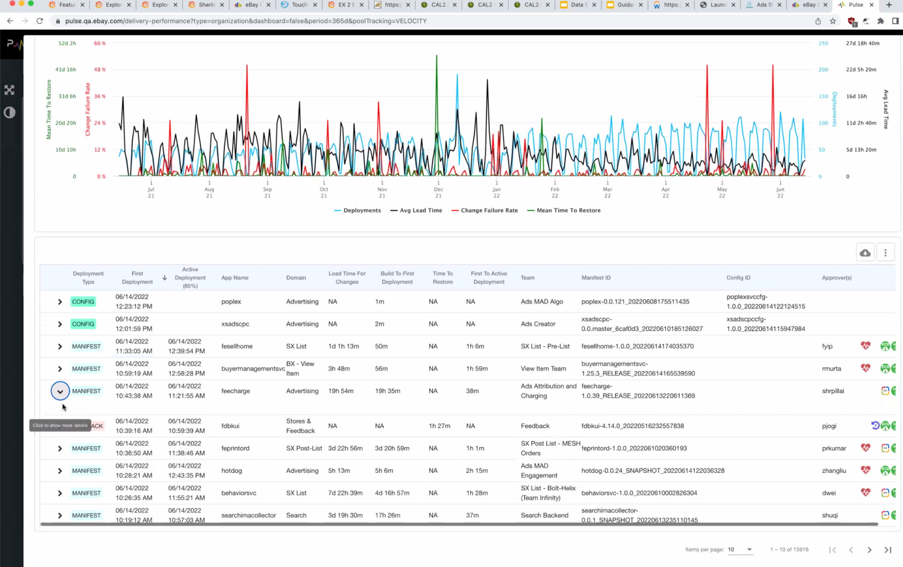

As long as the build Id and manifest Id are the same, yes.

Look at time to detect, time to restore, time to fix.

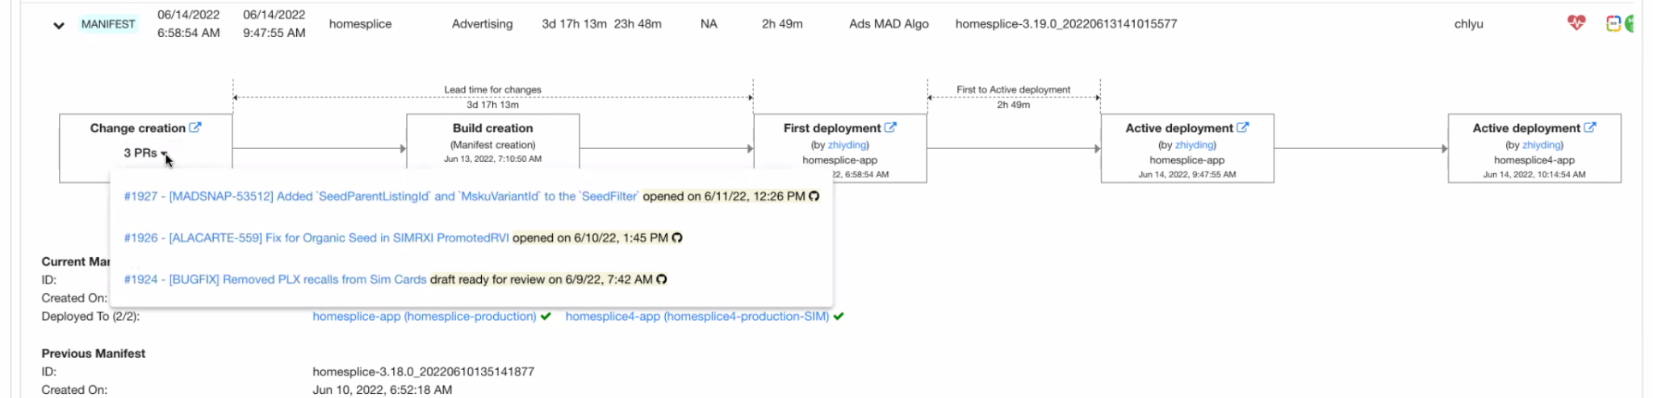

Each EP should be tied to pagerduty

Each feature flag should be tied to pagerduty

Ads currently have 11 teams in pagerduty

Bring down 3 days to 1 hour. Big revenue loss averted

Automate the process of figuring out

To focus on a few

If signal takes a long time to come in, there would be more changes that come in.

EP data collection ON is captured, data collection OFF is not. Wire on wire off

Canary Rollouts for EP change

We would like to add those such as feature flag, with lead time that is 0

What is the next small step towards this goal?

This EP is impacting these particular pools that belong to particular domain

Wanting to integrate feature flag

Tie errors rate in CAL dependencies

What data to pull out in CAL log and create a schema for that

EP page troubleshooting demo

So that everybody that uses touchstone,

<https://touchstone-api.vip.ebay.com:8080/api/v1/tsexperiments/100725>

Feature flag

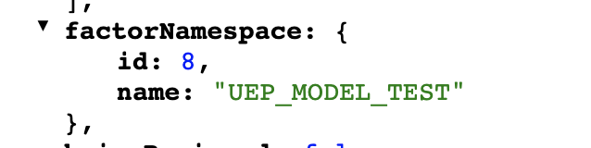

You will see UEP_MODEL_TEST as EP feature flag under the Implementation tab.

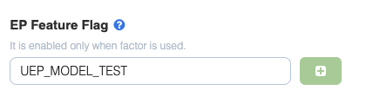

For your info, EP feature flag is different from Audience Aware Feature Flag (the one we are interested as per the meeting earlier) but the underlying data storage for both is the same.

The API I shared is basically fetching all metadata related to an experiment. There is plan for supporting experiment in AAFF, which eventually will share the same TS API. When the support is available, you may simply the below in your dashboard

* look for AAFF key in factorNameSpace
* check for "fromFeatureFlag": **true**,

For now, I can see that TS is using another API for fetching AAFF - which contains AAFF in the name field (see screenshot).

